       MODULE 5) HTML 5

**Q-1   What are the new tags added in HTML5?**

**Ans.**

   The following tags (elements) have been introduced in HTML5 −

|  |  |
| --- | --- |
| Tags (Elements) | Description |
| <article> | Represents an independent piece of content of a document, such as a blog entry or newspaper article |
| <aside > | Represents a piece of content that is only slightly related to the rest of the page. |
| <audio> | Defines an audio file. |
| <canvas> | This is used for rendering dynamic bitmap graphics on the fly, such as graphs or games. |
| <command> | Represents a command the user can invoke. |
| <datalist> | Together with the a new list attribute for input can be used to make comboboxes |
| <details> | Represents additional information or controls which the user can obtain on demand |
| <embed> | Defines external interactive content or plugin. |
| <figure> | Represents a piece of self-contained flow content, typically referenced as a single unit from the main flow of the document. |
| <footer> | Represents a footer for a section and can contain information about the author, copyright information, et cetera. |
| <header> | Represents a group of introductory or navigational aids. |
| <hgroup> | Represents the header of a section. |
| <keygen> | Represents control for key pair generation. |
| <mark> | Represents a run of text in one document marked or highlighted for reference purposes, due to its relevance in another context. |
| <meter> | Represents a measurement, such as disk usage. |
| <nav> | Represents a section of the document intended for navigation. |
| <output> | Represents some type of output, such as from a calculation done through scripting. |
| <progress> | Represents a completion of a task, such as downloading or when performing a series of expensive operations. |
| <ruby> | Together with <rt> and <rp> allow for marking up ruby annotations. |
| <section> | Represents a generic document or application section |
| <time> | Represents a date and/or time. |
| <video> | Defines a video file. |
| <wbr> | Represents a line break opportunity. |

New types for <input> tag:

The input element's type attribute now has the following new values –

|  |  |
| --- | --- |
| Type | Description |
| color | Color selector, which could be represented by a wheel or swatch picker |
| date | Selector for calendar date |
| datetime-local | Date and time display, with no setting or indication for time zones |
| datetime | Full date and time display, including a time zone. |
| email | Input type should be an email. |
| month | Selector for a month within a given year |
| number | A field containing a numeric value only |
| range | Numeric selector within a range of values, typically visualized as a slider |
| search | Term to supply to a search engine. For example, the search bar atop a browser. |
| tel | Input type should be the telephone number. |
| time | Time indicator and selector, with no time zone information |
| url | Input type should be URL type. |
| week | Selector for a week within a given year |

**Q-2  How to embed audio and video in a webpage?**

**Ans.**

**Audio in a webpage:**

              To embed audio in HTML, we use the <audio> tag. Before HTML5, audio cannot be added to web pages in the Internet Explorer era. To play audio, we used web plugins like Flash. After the release of HTML5, it is possible. This tag supports Chrome, Firefox, Safari, Opera, and Edge in three audio formats – MP3, WAV, OGG. Only Safari browser doesn’t support OGG audio format.

**EX..**

<!DOCTYPE html>

<html lang="en">

<head>

    <meta charset="UTF-8">

    <meta name="viewport" content="width=device-width, initial-scale=1.0">

    <title>Document</title>

</head>

<body>

    <audio controls>

        <source src="biodynamic-impact-braam-tonal-dark-176441.mp3" type="audio/mp3">

    </audio>

</body>

</html>

**Output:**

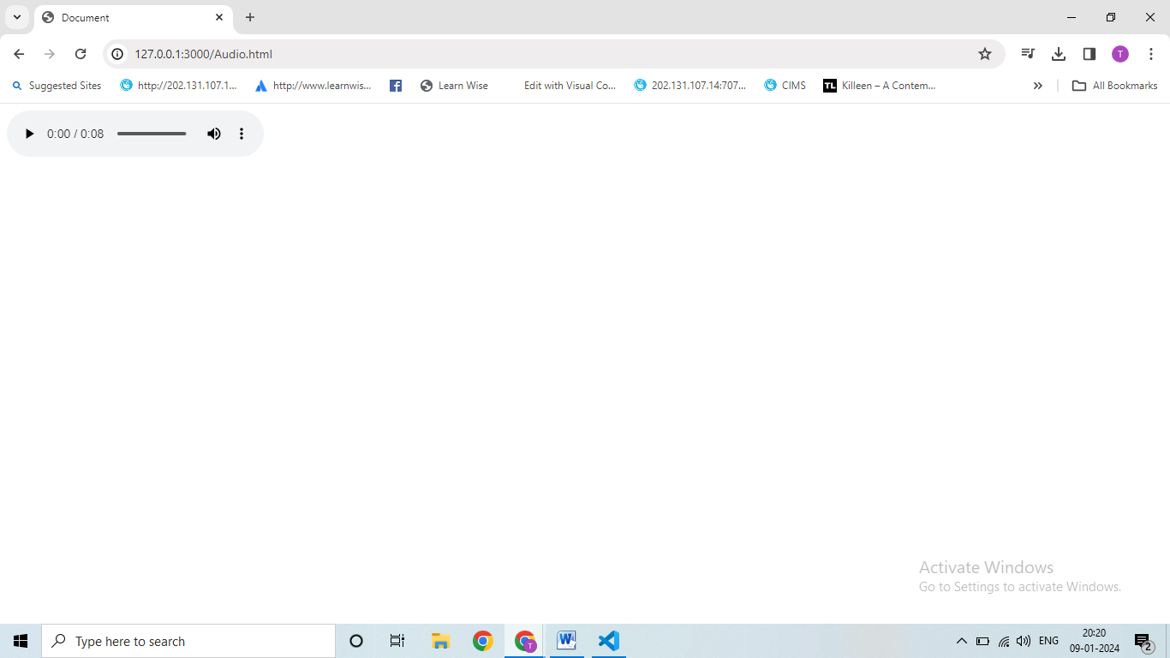

**Video in a webpage:**

            To embed video in HTML, we use the <video> tag. It contains one or more video sources at a time using <source> tag. It supports MP4, WebM, and Ogg in all modern browsers. Only Ogg video format isn't supported in Safari browser.

**EX..**

**<!DOCTYPE html>**

**<html lang="en">**

**<head>**

**<meta charset="UTF-8">**

**<meta name="viewport" content="width=device-width, initial-scale=1.0">**

**<title>Document</title>**

**</head>**

**<body>**

**<video width="320" height="240" controls>**

**<source src="video (1080p).mp4" loop>**

**</video>**

**</body>**

**</html>**

**Output:**

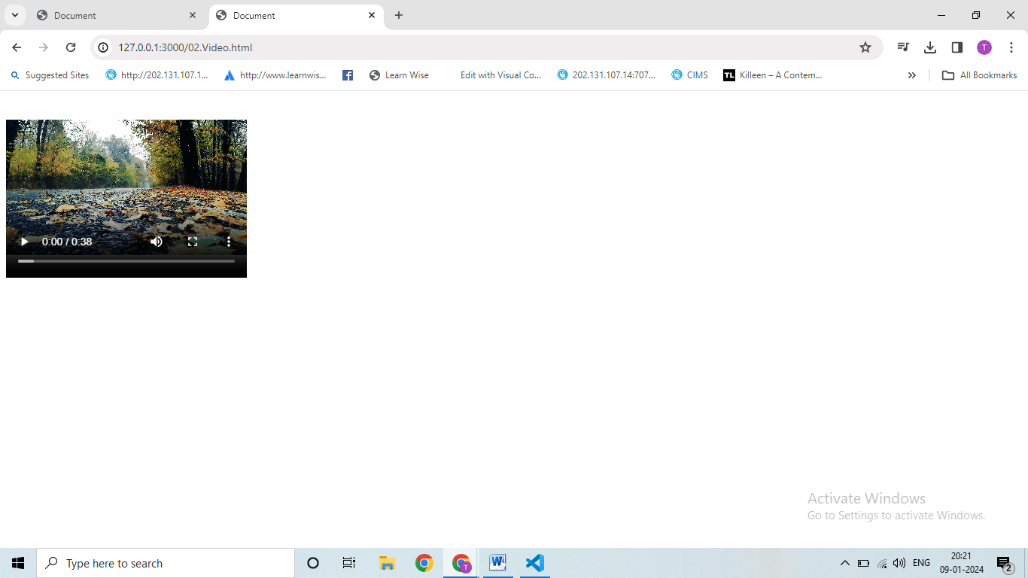

**Q-3 Semantic element in HTML5?**

**Ans.**

A semantic element clearly describes its meaning to both the browser and the developer.

1. <article>

2. <aside>

3. <details>

4. <figcaption>

5. <figure>

6. <footer>

7. <header>

8. <main>

9. <mark>

    10 .<nav>

    11.<section>

    12.<summary>

    13.<time>

**Q-4**  **Canvas and SVG tags.**

**Ans.**

**Canvas tags:**

        The HTML <canvas> element is used to draw graphics, on the fly, via scripting (usually JavaScript).The <canvas> element is only a container for graphics. You must use a script to actually draw the graphics.Canvas has several methods for drawing paths, boxes, circles, text, and adding images.

            Canvas can draw colorful text, with or without animation.

            Canvas has great features for graphical data presentation with an imagery of graphs and charts.

            Canvas objects can move. Everything is possible: from simple bouncing balls to complex animations.

            Canvas can respond to JavaScript events.

           Canvas can respond to any user action (key clicks, mouse clicks, button clicks, finger movement).

            Canvas' methods for animations offer a lot of possibilities for HTML gaming applications.

**EX..**

**<!DOCTYPE html>**

**<html lang="en">**

**<head>**

**<meta charset="UTF-8">**

**<meta name="viewport" content="width=device-width, initial-scale=1.0">**

**<title>Document</title>**

**</head>**

**<body>**

**<h1>HTML5 Canvas tags</h1>**

**<canvas id="myCanvas" width="200" height="100" style="border:1px solid #000000;"></canvas>**

**</body>**

**</html>**

**Output:**

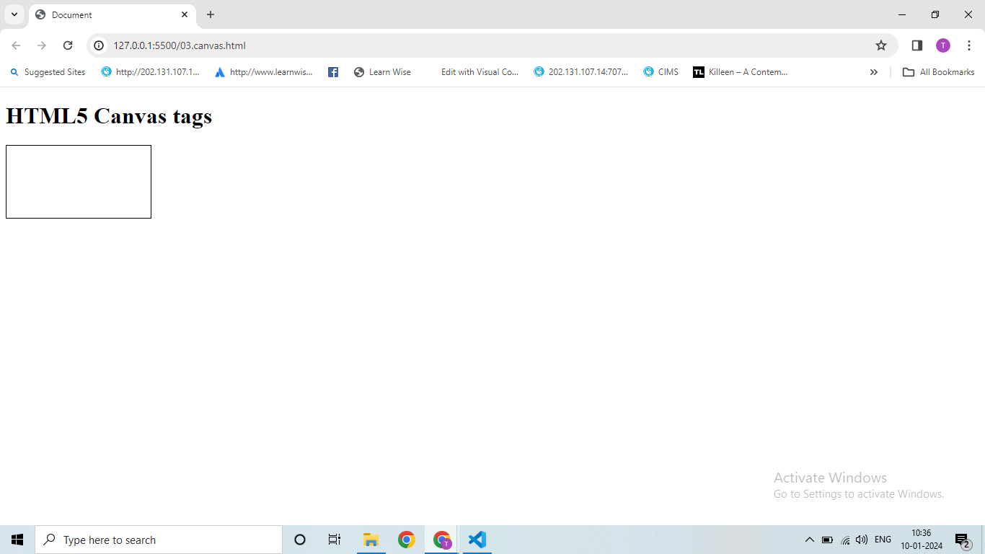

**SVG tags:**

     SVG stands for Scalable Vector Graphics.SVG is used to define graphics for the Web.SVG is a W3C recommendation.

       The HTML <svg> element is a container for SVG graphics.

       SVG has several methods for drawing paths, boxes, circles, text, and graphic images.

**EX..**

**<!DOCTYPE html>**

**<html lang="en">**

**<head>**

**<meta charset="UTF-8">**

**<meta name="viewport" content="width=device-width, initial-scale=1.0">**

**<title>Document</title>**

**</head>**

**<body>**

**<svg width="400" height="180">**

**<rect x="50" y="20" rx="20" ry="20" width="150" height="150"**

**style="fill:red;stroke:black;stroke-width:5;opacity:0.5" />**

**</svg>**

**</body>**

**</html>**

**Output:**

